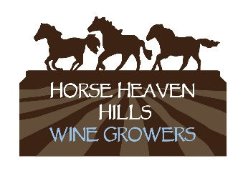
Horse Heaven Hills AVA Statistics

Ava & climate

Land Size: 50 miles wide by 20 miles deep
Elevation: 300 to 1,800 feet
North Border: Columbia Valley and Yakima AVA’s
South Border: Columbia River

Total Acreage: 570,000
Planted Acreage: Approximately 16,000 of Washington acreage
Oldest Block: 1972 planted by Don and Linda Mercer

Number of Vineyards: 31
Number of Wineries: 5

Heat Units: Average 3000 annually
Rain: 6 to 9 inches, primarily in winter months
Wind: 30% more than other regions---We welcome the breezes that blow through our region. It is one of the distinguishing factors of our AVA

Red Varieties
Total # Planted: 25
Total Acreage: 11,000 (73%)

Top 5: Cabernet Sauvignon, Merlot, Syrah, Cabernet Franc & Malbec

Additional: Barbera, Carignane, Carmenere, Cinsault, Counoise, Dolcetto, Graciano, Grenache, Lemberger, Marquette, Mourvedre, Nebbiolo, Petit Verdot, Pinot Noir, Sangiovese, Tempranillo & Zinfandel

White Varieties
Total # Planted: 13
Total Acreage: 4,000 (27%)

Top 5: Chardonnay, Riesling, Sauvignon Blanc, Pinot Gris & Viognier

Additional: Albarino, Gewurtztraminer, Marsanne, Muscat Canelli, Orange Muscat, Roussanne, Semillon & Chenin Blanc

Horse Heaven Hills Wine Growers/1201 Alderdale Road/Prosser, WA 99350
www.horseheavenhillswinegrowers.org

